Health and Wellness Application for Graduate Students

Submitted by: Shubham Gupta,

Shubhi Jain, Vineet Kaushik

# Problem and Solution Overview

Our product is designed to create a healthy lifestyle for graduate students. It is not news that pursuing a graduate degree is emotionally, psychologically, and physically taxing.Often when students get busy, exercise and good nutrition are the first things that go out the window. But we have to remember that healthy living is important for optimum performance at work or school. Additionally, keeping up with an exercise and diet regimen helps us deal with the stress that is often associated with graduate life. Not only does our product aim to offer the ability to maintain a healthy lifestyle through reminders for timely consumption of water and meals, it also assists users to track their calories and alcohol levels. Moreover, we also intend to help students to schedule time for exercise in addition to suggesting them workouts. Finally, users will also be provided healthy and quick recipes and diagnosis along with remedies for common ailments.

# Potential Users

While the system is primarily designed for graduate students, it could also be used by a number of people who have a strict job schedule. This could be bartenders, restaurant managers and workers and others employed in the hospitality sector. Physicians and nurses are also prone to working at odd hours. Another example occupation could be truck drivers. In fact anyone who wants to lead a healthy lifestyle and wants an application to to help him monitor his lifestyle will benefit from this application. Anybody familiar with android platform and has a smartphone will be able to use the application. The application does not require any training before using, it is going to be a user friendly application and will guide the user to each process and feature on its own. User should be familiar with interacting with android applications.   
  
**Literature**

As expected, we found a variety of academic papers relating to health and wellness of students.

**Paper 1: A survey of junior high school students’ sleep habit and lifestyle in Okinawa**

Masashi Arakawa1, Kazuhiko Taira PhD et al.

In this a paper a survey was made and found that bed times of higher grade students are typically later which resulted in greater numbers of sufferings from insufficient sleep, difficulty in waking up, failing to eat breakfast etc. It also contributed to poor dietary habits, feeling ill and sleepiness during day.

**Impact:** This source was relevant to our project because it helped us to understand that for a healthy lifestyle its important to sleep on time and eat breakfast on time. Strengthened our idea for meal tracker feature. Possibly can think for a personalized alarm clock for user’s lifecycle.

**Paper 2: Television Viewing and its Associations with Overweight, Sedentary Lifestyle, and Insufficient Consumption of Fruits and Vegetables Among US High School Students: Differences by Race, Ethnicity, and Gender**

Richard Lowry, Howell Wechsler, Deborah A. Galuska, Janet E. Fulton and Laura Kann

In this paper it was observed that TV viewing has been associated with overweight, decreased physical activity and unhealthy dietary behavior. Students from different races, ethnic groups and gender were examined in United States. It was found that it was associated with being overweight and eating insufficient fruits and vegetables.

**Impact:** This helped us to understand the demographics of our potential users. Also emphasizes on the importance of exercise and eating fruits and vegetables. Idea for healthy food recipes came from this research. Also our idea of an exercise reminder and reminder for fruits/snacks is supported by this research because graduate students also sit a lot in front of Laptops.

**Paper 3: Happiness and health behaviors in Chilean college students: A cross-sectional survey**

José A Piqueras et al.

In this paper to examine happiness and health behavior of students, healthy behavior indexes were assessed such as daily physical exercise, fruits/vegetables intake, breakfast and lunch intake, smoking, alcohol and other drugs consumption, perceived stress and Body Mass Index. These variables were accounted to promote health education in university

**Impact:** This source was relevant to our project because it helped us to decide what indexes actually should be accounted for when considering health for students. Alcohol tracker feature idea was thought of after reading this paper. Also in future can think of implementing a smoke quitter/controller app.

**Paper 4: The Relation Between Health-Promoting Lifestyle and Quality of Life in Undergraduate Students at School of Health, Isfahan University of Medical Sciences**

Tol Azar, Tavassolielaheh Shojaezadeh Davood

In this paper Health Promoting Lifestyle was introduced which consists of 6 aspects including physical activity, nutrition, health responsibility, interpersonal relations and stress management. The study aimed to determine the relation between health promoting lifestyle behaviors and quality of life among students.

**Impact:** Understood that mental wellness of students is equally important. For Stress management spiritual, physical and mental health indexes should be considered.

**Paper 5: Self-medication amongst students of Karachi: prevalence, knowledge and attitudes**

Syed Nabeel Zafar, Aga Khan University et al.

In this paper students were examined for prevalence of self-medication and it was found to be 76% which is high. It was also realized that there is a need to educate youth to ensure safe practices. Strict policies ned to be implemented on the advertising and selling of medications to prevent this problem from escalating.

**Impact:** Helped us to understand that that it is important to have a safe medical diagnosis and recommend homemade and safe remedies for common ailments among students.

**Paper 6: Exploring the effects of stress on Mood, Self Esteem, and Daily habits with Psychology Graduate Students**

Charla McKinzie (Bowie State University) et al.

In this paper stress among students was examined and it was found that it is related to feelings of irritability, impulsiveness, emotional instability, nervousness etc. It was also found that graduate students have greater negative effect from stress which also takes on irregular sleep pattern and development of habits such as alcohol and cigarette consumption.

**Impact:** Helped us to devise methods for reducing stress among students. Found that healthy lifestyle helps to fight depression. So, our own suggestions in a schedule feature for a healthy lifestyle came from this research.

# User Research Method: Contextual Task Analysis

The four principles of contextual inquiry are:  
Focus - Plan for the inquiry, based on a clear understanding of your purpose  
Context - Go to the customer's workplace and watch them do their own work  
Partnership - Talk to customers about their work and engage them in uncovering unarticulated aspects of work  
Interpretation - Develop a shared understanding with the customer about the aspects of work that matter

**Reason for selecting**

This user research method applies ethnographic observation and one-on-one interviewing to understand the task procedures that users follow to reach their goals. This method allows us to silently observes the user at work in his or her natural work environment and we can make notes of any tools and people that support the user as they work toward task goals. This gave us a better insight into a graduate student’s lifestyle and his viewpoints and made us come up with all features that aids students to lead a healthy lifestyle.

**Rationale behind choice of users**

We sought users who are representative of the target market for our application. In particular, we sought out students who were busy with their academic workload and extra curricular activities and seem to be stressed about it. We also searched for people who represented different ages, careers and degrees of proficiency with technology.

**Backgrounds of users**

We conducted four interviews, one with an undergraduate student, and three with graduate students.

The undergraduate is a sophomore in the engineering department. She has a moderate class load this semester, but also works in a student computer center three days a week. She has to plan a lot of events in advance.

The graduate is pursuing a master’s degree in Mechanical Engineering. He is a sports player but here due to his hectic schedule he does not get enough time to practice his sport regularly which makes him more stressed and guilty.

The other graduate student is getting a master’s degree in Computer Science and also works part- time doing research. He is married, so he has to share his schedule with his wife. He is in his mid-thirties. According to him his and wife’s eating and exercise habits has changed a lot since he enrolled as a student at the university.

The other graduate student is pursuing a management degree. He thinks that he generally does not have time to take meals and often skips meals. He binges on sweets whenever he has the time. Also, he likes to drink and hit the gym often.

**Contextual Inquiry**

**Process and environment**

All of our interviews were conducted in the universities of the users and their homes, often in the libraries and their workspace. The user daily activities were observed. We tried to be as discreet and respectful as possible. Our interviews were typically conducted by two team members. A typical interview would begin by asking the user to briefly list all the measures that they take to live a healthy lifestyle. We would then have the user explain what sort of thoughts led to each measure. We would observe how they execute that measure and ask questions about anything that we did not understand or found particularly interesting.  
Then user was asked if he already used any health or lifestyle app. For each app, he or she would then go through the steps of describing why he chose that app, and explain how the app was successful or unsuccessful. We typically concluded our interviews by thanking our users and presenting to them the idea of a health and wellness app for graduate students. We would gather the users’ impressions of the idea and ask for suggestions.

**Common tasks**

**Morning**

All of our users had to go to universities or work around 9:00 am. They were typically getting up an hour before they had to leave and rush towards their destination. One of the user drank warm water after she woke up. None of them had their breakfast in the morning because they were already running short of time. A few of them packed some fruits, nuts and snacks to eat. After their first few lectures, we interviewed them and according to them they were feeling tired, sleepy, could not pay attention and hungry so they grabbed a cup of coffee or some snacks and continued with their work/lectures. After a few hours, some of them did a brunch while others continued with their activities. Most of them did not even drink water till 3-4 hours. Because they woke up just an hour before, they did not have time to have a healthy breakfast or go to gym/walk.

Breakfast is the most important meal of the day. Also, there are lots of studies that show if you do some exercise in the morning, you will be in a better mood all day long.

**Afternoon**

Around 1-2 pm mostly everyone was done lectures and one of them went back home to cook food. He generally either eats frozen food or cook a meal that takes less time and ingredients (Example: Noodles, rice). One of them ate at Krishna Lunch which generally provides a wholesome healthy meal including salads and desert. He generally prefers Krishna lunch because its healthy, cheap and convenient. The management guy decided to skip the meal as he had to go to a workshop so he just had a protein bar. The undergraduate girl decided to go to an info session of a company that will provide refreshments(pizza). According to her, it will save her from cooking or buying food. Also pizza is her favorite snack. They had almost 2-4 glasses of water till now.

Taking a lunch break, or even multiple short breaks throughout the day, provides an opportunity for our brains to recuperate.

**Evening**

One of the user decided to skip class and take a nap after eating lunch. Mostly all of them had an evening snack or fruit and continued with their busy day. Some of them went to gym or played some sport for recreation. All of them had dinner and one of them had some beers. All of them generally went to bed around 12-2 am. Most of our users had around 4-6 glasses of water.

Busy days can force us to push our workouts toward the end of the day.

**Users with health apps**

Two users had health apps in their phones

“Water me”: This user had the largest intake of water during the day. A notification after a regular interval reminded user to drink water. In this way user was able to have the fulfil the requirement of having 8 glasses of water daily.

Since our bodies need water to function, not drinking enough water prevents us from functioning optimally.  
“Calorie counter” : This user was trying to shed a few pounds and that app helped him to keep track of the calories and informs him that the number of calories he should intake according to his current weight and height. This person eats a healthy diet.

**Unique features of individual interviews**

One user said that not having breakfast in the morning actually made her feel light because after eating food she generally feels sleepy. She says “If I eat breakfast (no matter if its all Primal or not) I have less energy in the mornings and actually am hungrier by the time lunch hits than when I skip it. For me coffee with a couple tablespoons of cream really just does the trick. I always have plenty of energy and am wide awake and grooving along until lunch hits about 5 hours later.”

Another user believes that occasionally skipping one or two meals in a row could benefit in weight loss. According to him “If you have skipped a meal, the body will draw from your fat reserves to meet your energy needs.”

**Context of Use**

In the above discussed morning, afternoon and evening scenarios if the user uses our application, it will help user to fight stress by eating on time and eating healthy. Also, if the user falls sick, he can consult the diagnosis app feature and can prepare some home remedy for a flu, cut or common ailment. If the students want to consume alcohol, our application will help him monitor his drinking. All this features can be used by a student in a day-to-day basis.

**Task Analysis Questions**

*Who is going to use the system?*

The users are going to be students specifically those pursuing a graduate degree.

*What tasks do they now perform?*

Presently, some users maintain their health and fitness through a wide variety but generic apps while others use their own intuition.

*What tasks are desired?*

Graduate students are usually caught up with coursework, assistantships and research and are thus unable to manage the task of scheduling and following their diet on time and an exercise plan.

*How are the tasks learned?*

Students like everyone else have to work hard to create a habit of exercising regularly. They have to plan their schedule before the start of a semester/year/project and keep working daily on it and as the time goes our bodies generate some sort of stimulus to keep them on track eg. feeling of discomfort when missing a workout or skipping a meal.

*Where are the tasks performed?*

Students usually create their schedule while at their desks or while carrying out passive actions such as commuting. Being reminded and staying mindful of one's schedule can happen anywhere.

*What’s the relationship between user & data?*

The data represents their schedule, diet as well as essential indicators of their health such as calorie intake, sleep cycle, fluid intake and previous ailment search history.

*What other tools does the user have?*

Apart from a smartphone, users also have a laptop/PC and probably a tablet.

*How do users communicate with each other?*

Users usually write their schedules on notepad like applications on their devices or actual notepads or post-it notes. While communicating, users usually show people their schedule through applications on their devices or directly talk to others about their schedule.

*How often are the tasks performed?*

Users may update their schedules more frequently at the beginning of the semester to test the effectiveness of a schedule. However, they do not update their schedule as much in the middle of the semester and use mental notes instead to get reminders, stay on track with their fitness goals and diet, read recipes from online blogs or find wellness center nearby using applications like Google maps.

*What are the time constraints on the tasks?*

Time constraints on tasks is fairly strict as users want to create/update schedules or access reminders in the quickest manner possible. While they could use their commute time to handle such tasks, no one usually carries their schedules on their person unless they have stored it in their smartphones/tablets.

*What happens when things go wrong?*

Graduate students in particular have excessive workload and thus have difficulty staying on track with their health and fitness. Losing their schedule or being forced to skip a meal or missing a task on their regimen could result in demotivation. This could lead them to break their diligence in following the regimen they have set for themselves.

# User Research Method: Survey

The primary advantage of surveying a population is the ability to produce large amounts of quantitative data, such as numerical ratings.

**Reason for selecting**

Adding this tool to the ethnographic toolbox makes it easier to draw quantitatively meaningful, statistically significant conclusions from research.

**Objective:** To understand students drinking, eating habits and the lifestyle they follow so as to determine the necessity and usefulness of the application. Asking for suggestions and recommendations as to what kind of features would the user prefer in an ideal health and wellness application will help us incorporate the right features.

**Planning:** Questionnaire was formed by the team members through brainstorming the ideas. Most of the questions were multiple choice enabling the user to understand the perspective of the question better and select the appropriate answer after relating the question to their lifestyle. A few questions were open ended questions asking for user’s suggestions and options. 13 questions were asked which were relevant and sufficient enough to get the insight into the lifestyle of the participant. We used an online tool called TypeForm to create, design and share the survey.

**Methodology:** The survey was designed for undergraduate and graduate students and was shared on various UF Facebook groups and other colleges in India and USA so that the survey reaches the target population. Approximately 70 responses were collected. Sample size was large enough to conclude results with precision.

**Survey Results:**

* 74% of the participants did not use any health or fitness applications, while the other 26% used apps like Strava, My Fitness Pal, Water Drink.
* 26% participants did not eat outside at all, while 22% eat outside daily. 39% participants eat food outside 1-3 times/week, while 13% of the participants eat outside 4-6 times/week.
* 78% of the participants do not follow a special diet while 22% do.
* 13% participants always skip breakfast, while 83% people sometimes skip. 43% people often eat breakfast, while 26% people always eat breakfast.
* 86% participants always eat lunch, while only 9% eat lunch sometimes.
* 86% participants always eat dinner, while only 9% skip dinner sometimes.
* 48% participants cook meal daily, 35% cook sometimes and 17% never cook their meals.
* 39% participants often look for healthy recipes when they cook or eat, 35% look sometimes and 17% never look while only 9% always look for healthy recipes.
* 41% participants exercise 2-3 times a week, while 9% exercise 4-6 times a week. 36% never exercise while only 14% exercise daily.
* 41% of the participants fall sick mostly during seasonal changes while 9% fall sick many times a month. 41% fall sick rarely.
* **Only 23% of the participants feel that they lead a fairly healthy lifestyle while 36% feel they do not. 41% could not decide.**
* Features on application based on popularity:

1. Water/fluid reminder: 76%
2. Calorie count: 62%
3. Tracking exercises: 57%
4. Diagnosis and remedies for common ailments: 52%
5. Reminder for workouts: 52%
6. Healthy recipes: 48%
7. Alcohol tracker: 33%
8. Nearby wellness centers: 33%
9. Sexual Health: 24%

**Conclusions:**

Based on the survey results, it was found that the context of use of the application will be on a regular basis. Users were asked to rank features that they like to see in an application. Their daily requirements for the features was judged on the basis of their response and also the alternative approaches that they use were understood and we came up with options that according to responses and our judgment were considered optimum in those typical situations. For example, if a student cook food at home and consults YouTube for viewing recipes, he cannot add filters like “minimum ingredients” or “cheap alternative” or “easy and quick to cook”, but our application will take notes on these things beforehand and provide students with optimum results.

**Design Requirements**

**Primary features (Must Have)**

The application must have a mechanism to remind students about imminent items listed on their schedules eg drink water, eat a fruit. Another mandatory feature is keeping track of exercises along with calories consumed and calories burnt through work out or other forms of physical exertion. Students can be reminded to update their calorie count a few minutes after their work out. Given features such reminders and the ability to monitor their workout and calories, the application should also have an integrated schedule planner for easier/quicker navigation.

The nature of disruption that is inherent of reminders could in turn be a reason for major failure of this application. Reminders that are too disruptive or frequent could be detrimental to experience of a student. Students wouldn't want their phones buzzing too loudly or frequently while in the classroom or a lab. Care must be taken to set reminder frequency and intensity according to the user's preference.

Reminders can scheduler that is difficult to navigate and use could be the major sticking point of the application.

**Secondary features (Should Have)**

Additionally, the application should also have features to regulate alcohol consumption It should also have a feature to recommend healthy recipes based on the user's diet preferences, which can be saved by users for later reference. Also, as graduate students tend work and be alone most of the time, they should be given a feature to diagnose and remedy common illnesses.

These features will be used on an as need basis. Gauging alcohol consumption incorrectly could result in a student getting more drunk than they would prefer. Regarding recipe suggestions, failure to provide novel recipes consistently could prove troublesome.

Misdiagnoses is a damaging failure. A wrong remedy suggested on the basis of a misdiagnoses could have severe health and legal ramifications.

**Additional features (Could Have)**

For a more cohesive experience the application could also have a feature to find nearby wellness centers/pharmacies. It could also contain a feature that helps the user to monitor their sexual health.

These features will also be used on an as need basis. Depending on their immunity, students may use the find nearby centers feature once a month or during seasonal changes. Usage of the alcohol and sexual health monitors will depend entirely on the user's habits.

Any mistakes in suggesting a pharmacy would weaken the user's trust in the feature.

APPENDIX

**Photos from Ethnography**

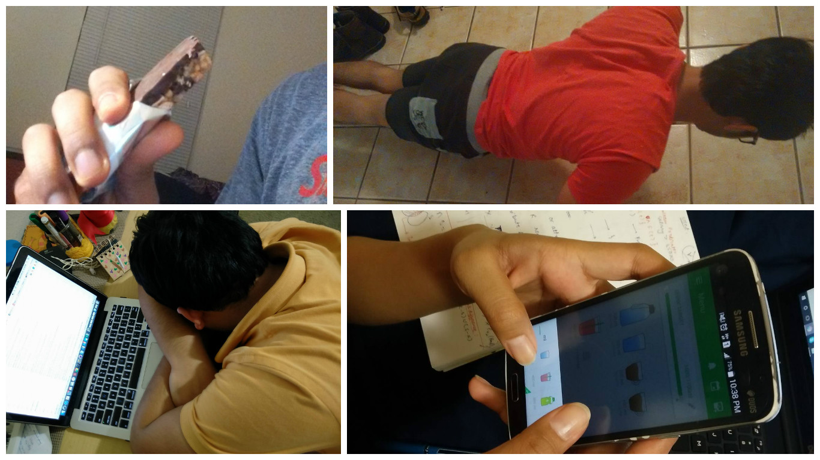

a. Student eating a protein bar before going to college as substitute for breakfast.  
b. Student exercising late at night at his home.  
c. Student sleeping at his office due to sleeping late last night and not eating breakfast in the morning.  
d. Student using a “WaterMe” application showing that she had already taken six glasses of water today and reminding her to take two more.

**Survey Questions**

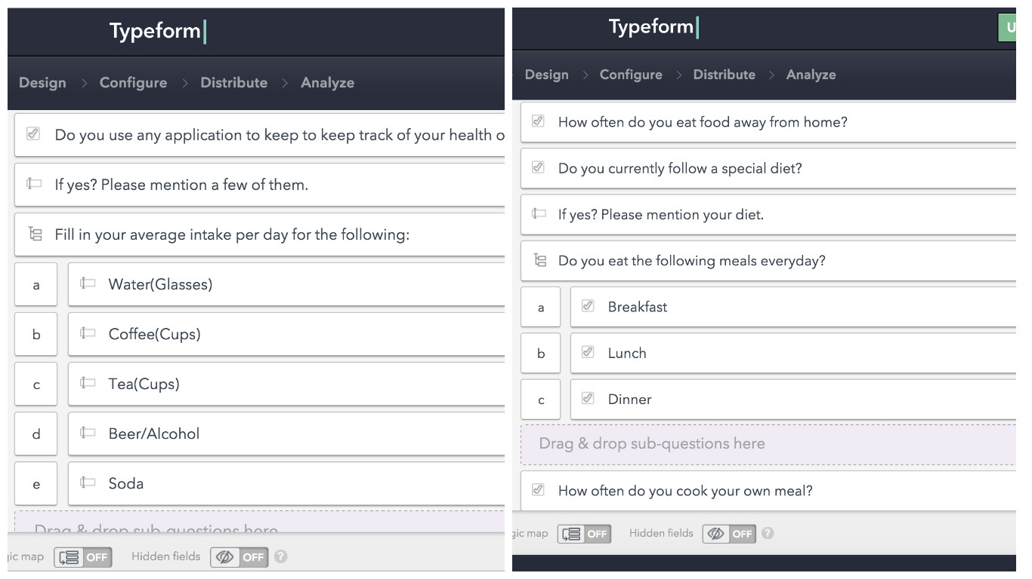

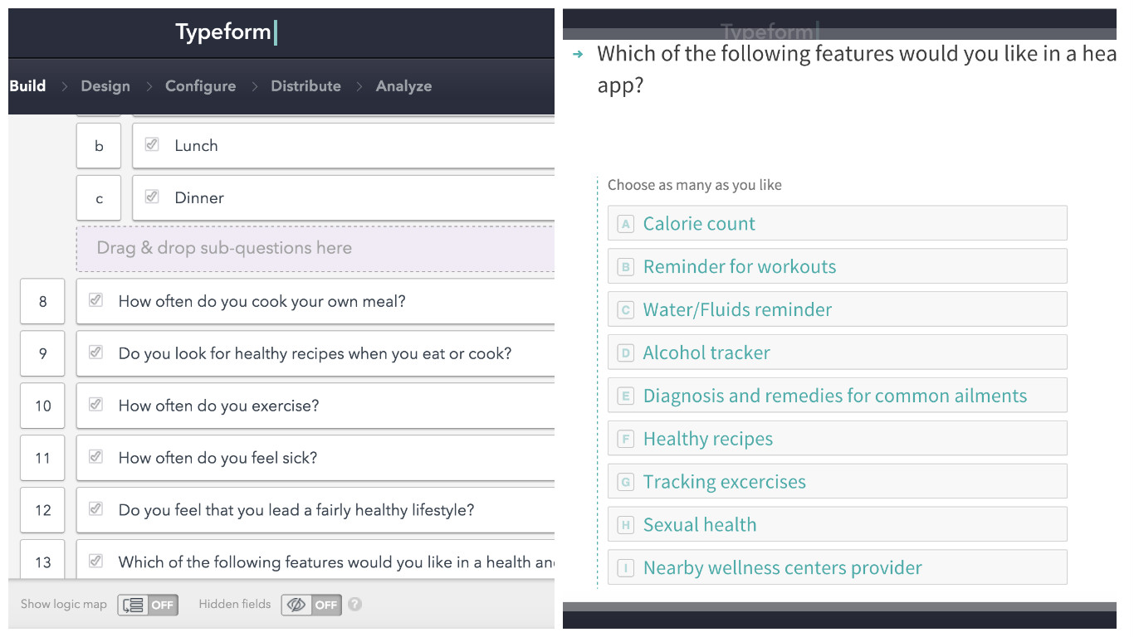

Survey Link: <https://shubhamg.typeform.com/to/OZAcwH>

**Interview Questions and Raw Observations**

